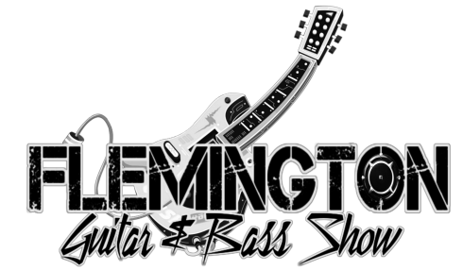
Exhibitor Agreement

Exhibitor Name: __________________________________________________

Exhibitor Contact: ________________________________________________

Address: ________________________________________________________

Phone: ______________________ Email: ________________________

I am a: RETAILER _____ LUTHIER _____ MANUFACTURER _____

...dealing primarily in (check all that apply): Electric _____ Acoustic _____

New _____ Used_____ Vintage _____ Amps _____ Accessories _____

Names of booth staff: ______________________________________________

- Booth pricing: $225 10’x10’ - $400 10’x20’ - $600 10’x30’

Booths reserved: _____ = ________

Chairs: 2 Provided
Electric: Provided (Always bring a power strip & extension cord just in case)

TOTAL ENCLOSED/Paid: _____________
(Paypal info.hvgs@gmail.com (Friend/Family)
Checks payable to: Empire Guitar Shows, LLC)

Location: Flemington Elks Lodge 165 NJ-31, Flemington, NJ 08822 (Food/Lodging all close)

Exhibitor signature: _______________________Date: ____________________

